

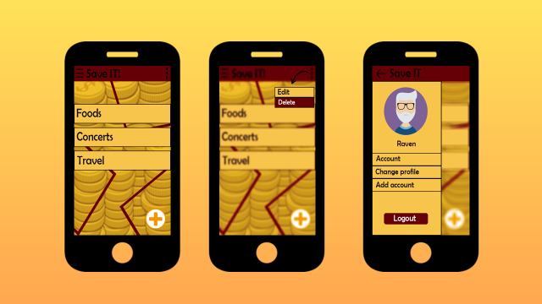

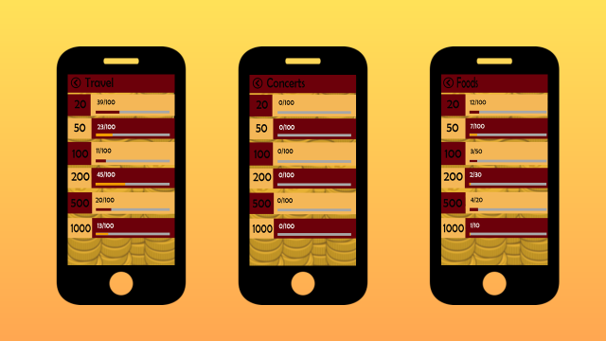

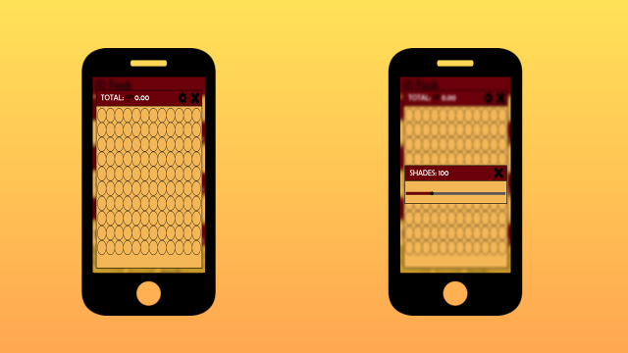

HCI Principles and Guidelines

In this application that I've created I consider some guidelines that will help the user to easily understand the basics of the app. These are the ff:

* **Display layout**

I make sure that the items are properly aligned and has a appropriate lengths in each page. Each page are pleasing to the eyes of the user because the display is in one particular side only of the page.

* **Graphical User Interface**

In this app I put only the important items or information to make it more simple because like my professor always says “Humans are incapable on handling too many information because it may be boring to them whenever they see a bunch of information gathering on one page of your application (ex. home)

* **User type**

Open for all user/ user friendly. No harmful content.

* **Platform/System set up**

This is only for mobile devices